**WEEK 2**

**PLSQL_Exercises**

**Exercise 1: Control Structures**

CREATE TABLE customers (

customer_id NUMBER PRIMARY KEY,

name VARCHAR2(50),

age NUMBER,

balance NUMBER(10, 2),

interest_rate NUMBER(5, 2),

isVIP VARCHAR2(5)

);

CREATE TABLE loans (

loan_id NUMBER PRIMARY KEY,

customer_id NUMBER REFERENCES customers(customer_id),

due_date DATE

);

INSERT INTO customers VALUES (1, 'Ravi', 65, 8000, 10.5, 'FALSE');

INSERT INTO customers VALUES (2, 'Sneha', 45, 12000, 9.0, 'FALSE');

INSERT INTO customers VALUES (3, 'Amit', 70, 15000, 8.5, 'FALSE');

INSERT INTO customers VALUES (4, 'Priya', 30, 5000, 11.0, 'FALSE');

INSERT INTO loans VALUES (101, 1, SYSDATE + 10);

INSERT INTO loans VALUES (102, 2, SYSDATE + 45);

INSERT INTO loans VALUES (103, 3, SYSDATE + 5);

INSERT INTO loans VALUES (104, 4, SYSDATE + 25);

COMMIT;

SET SERVEROUTPUT ON;

BEGIN

FOR cust IN (SELECT customer_id, interest_rate FROM customers WHERE age > 60) LOOP

UPDATE customers

SET interest_rate = interest_rate - 1

WHERE customer_id = cust.customer_id;

DBMS_OUTPUT.PUT_LINE('Discount applied to customer ID: ' || cust.customer_id);

END LOOP;

COMMIT;

END;

/

BEGIN

FOR cust IN (SELECT customer_id, balance FROM customers WHERE balance > 10000) LOOP

UPDATE customers

SET isVIP = 'TRUE'

WHERE customer_id = cust.customer_id;

DBMS_OUTPUT.PUT_LINE('VIP set for customer ID: ' || cust.customer_id);

END LOOP;

COMMIT;

END;

/

BEGIN

FOR loan_rec IN (

SELECT l.loan_id, c.name, l.due_date

FROM loans l

JOIN customers c ON c.customer_id = l.customer_id

WHERE l.due_date <= SYSDATE + 30

) LOOP

DBMS_OUTPUT.PUT_LINE('Reminder: Loan ID ' || loan_rec.loan_id || ' for customer ' || loan_rec.name || ' is due on ' || TO_CHAR(loan_rec.due_date, 'DD-Mon-YYYY'));

END LOOP;

END;

/

**Output:**

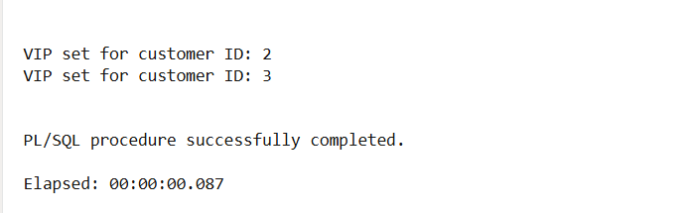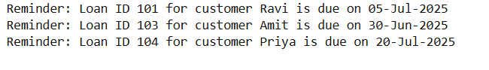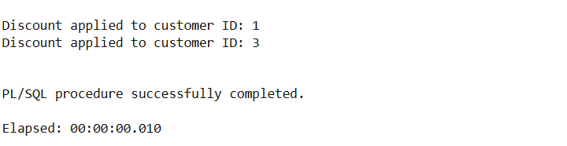

**Exercise 3: Stored Procedures**

BEGIN

EXECUTE IMMEDIATE 'DROP TABLE savings_accounts';

EXCEPTION WHEN OTHERS THEN NULL;

END;

/

CREATE TABLE savings_accounts (

account_id NUMBER PRIMARY KEY,

customer_id NUMBER,

balance NUMBER(10,2)

);

INSERT INTO savings_accounts VALUES (1, 101, 10000);

INSERT INTO savings_accounts VALUES (2, 102, 15000);

COMMIT;

BEGIN

EXECUTE IMMEDIATE 'DROP TABLE employees';

EXCEPTION WHEN OTHERS THEN NULL;

END;

/

CREATE TABLE employees (

emp_id NUMBER PRIMARY KEY,

name VARCHAR2(50),

department VARCHAR2(30),

salary NUMBER(10,2)

);

INSERT INTO employees VALUES (1, 'Alice', 'HR', 50000);

INSERT INTO employees VALUES (2, 'Bob', 'HR', 60000);

INSERT INTO employees VALUES (3, 'Charlie', 'IT', 70000);

COMMIT;

BEGIN

EXECUTE IMMEDIATE 'DROP TABLE accounts';

EXCEPTION WHEN OTHERS THEN NULL;

END;

/

CREATE TABLE accounts (

account_id NUMBER PRIMARY KEY,

customer_id NUMBER,

balance NUMBER(10,2)

);

INSERT INTO accounts VALUES (101, 1, 20000);

INSERT INTO accounts VALUES (102, 1, 5000);

COMMIT;

CREATE OR REPLACE PROCEDURE ProcessMonthlyInterest IS

BEGIN

FOR acc IN (SELECT account_id, balance FROM savings_accounts) LOOP

UPDATE savings_accounts

SET balance = balance + (balance * 0.01)

WHERE account_id = acc.account_id;

DBMS_OUTPUT.PUT_LINE('Interest applied to Account ID: ' || acc.account_id);

END LOOP;

COMMIT;

END;

/

CREATE OR REPLACE PROCEDURE UpdateEmployeeBonus (

dept_name IN VARCHAR2,

bonus_pct IN NUMBER

) IS

BEGIN

FOR emp IN (SELECT emp_id, name FROM employees WHERE department = dept_name) LOOP

UPDATE employees

SET salary = salary + (salary * bonus_pct / 100)

WHERE emp_id = emp.emp_id;

DBMS_OUTPUT.PUT_LINE('Bonus applied to ' || emp.name || ' in ' || dept_name);

END LOOP;

COMMIT;

END;

/

CREATE OR REPLACE PROCEDURE TransferFunds (

from_account IN NUMBER,

to_account IN NUMBER,

amount IN NUMBER

) IS

insufficient_funds EXCEPTION;

from_balance NUMBER;

BEGIN

SELECT balance INTO from_balance FROM accounts WHERE account_id = from_account;

IF from_balance < amount THEN

RAISE insufficient_funds;

ELSE

UPDATE accounts SET balance = balance - amount WHERE account_id = from_account;

UPDATE accounts SET balance = balance + amount WHERE account_id = to_account;

DBMS_OUTPUT.PUT_LINE('Transferred ' || amount || ' from account ' || from_account || ' to ' || to_account);

COMMIT;

END IF;

EXCEPTION

WHEN insufficient_funds THEN

DBMS_OUTPUT.PUT_LINE('Transfer failed: Insufficient balance.');

WHEN NO_DATA_FOUND THEN

DBMS_OUTPUT.PUT_LINE('Transfer failed: Account not found.');

END;

/

SET SERVEROUTPUT ON;

BEGIN

DBMS_OUTPUT.PUT_LINE('--- Executing: ProcessMonthlyInterest ---');

ProcessMonthlyInterest;

DBMS_OUTPUT.PUT_LINE(CHR(10) || '--- Executing: UpdateEmployeeBonus (HR, 10%) ---');

UpdateEmployeeBonus('HR', 10);

DBMS_OUTPUT.PUT_LINE(CHR(10) || '--- Executing: TransferFunds (101 -> 102, ₹3000) ---');

TransferFunds(101, 102, 3000);

END;

/

**Output:**

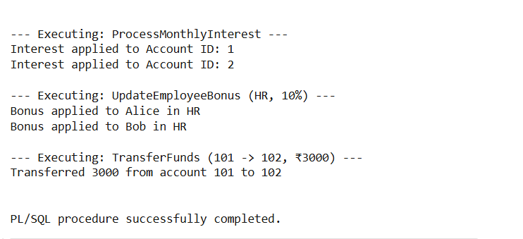

**JUnit_Basic Testing Exercises**

**EXERCISE 1: Setting Up Junit**

**Calculator.java:**

public class Calculator {

    public int add(int a, int b) {

        return a + b;

    }

}

**CalculaorTest.java:**

import org.junit.Test;

import static org.junit.Assert.*;

public class CalculatorTest {

@Test

    public void testAdd() {

        Calculator calc = new Calculator();

        int result = calc.add(3, 5);

        assertEquals(8, result);

    }

}

Output:

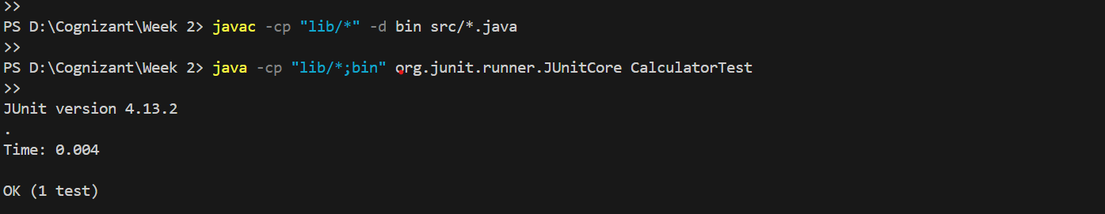

**Exercise 3: Assertions in JUnit**

import org.junit.Test;

import static org.junit.Assert.*;

public class AssertionsTest {

@Test

  public void testAssertions() {

        assertEquals(5, 2 + 3);

        assertTrue(5 > 3);

        assertFalse(5 < 3);

        assertNull(null);

        assertNotNull(new Object());

    }

}

Output:

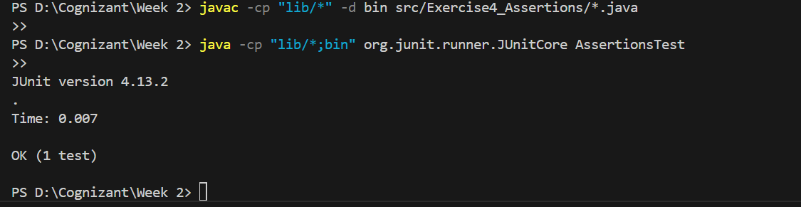

**Exercise 4: Arrange-Act-Assert (AAA) Pattern, Test Fixtures, Setup and**

**Teardown Methods in Junit**

**Calculator.java:**

public class Calculator {

    public int add(int a, int b) {

        return a + b;

    }

public int divide(int a, int b) {

        return a / b;

    }

}

**CalculatorTest.java:**

import org.junit.Before;

import org.junit.After;

import org.junit.Test;

import static org.junit.Assert.*;

public class CalculatorTest {

private Calculator calculator;

@Before

    public void setUp() {

        calculator = new Calculator();

        System.out.println("Setup complete");

    }

@After

    public void tearDown() {

        calculator = null;

        System.out.println("Teardown complete");

    }

   @Test

    public void testAddition() {

        int result = calculator.add(5, 3);

        assertEquals(8, result);

    }

@Test

    public void testDivision() {

    int result = calculator.divide(10, 2);

        assertEquals(5, result);

    }

    @Test(expected = ArithmeticException.class)

    public void testDivisionByZero() {

        calculator.divide(10, 0);

    }

}

Output:

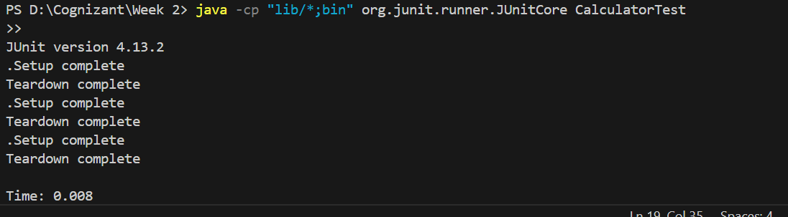

**Mockito exercises**

**Exercise 1: Mocking and Stubbing**

**ExternalApi.java**:

public interface ExternalApi {

    String getData();

}

**MyService.java:**

public class MyService {

    private ExternalApi api;

    public MyService(ExternalApi api) {

        this.api = api;

    }

    public String fetchData() {

        return api.getData();

    }

}

**MyServiceTest.java:**

import static org.junit.jupiter.api.Assertions.assertEquals;

import static org.mockito.Mockito.*;

import org.junit.jupiter.api.Test;

import org.mockito.Mockito;

public class MyServiceTest {

    @Test

    public void testExternalApi() {

        ExternalApi mockApi = Mockito.mock(ExternalApi.class);

        when(mockApi.getData()).thenReturn("Mock Data");

        MyService service = new MyService(mockApi);

        String result = service.fetchData();

        assertEquals("Mock Data", result);

    }

}

Output:

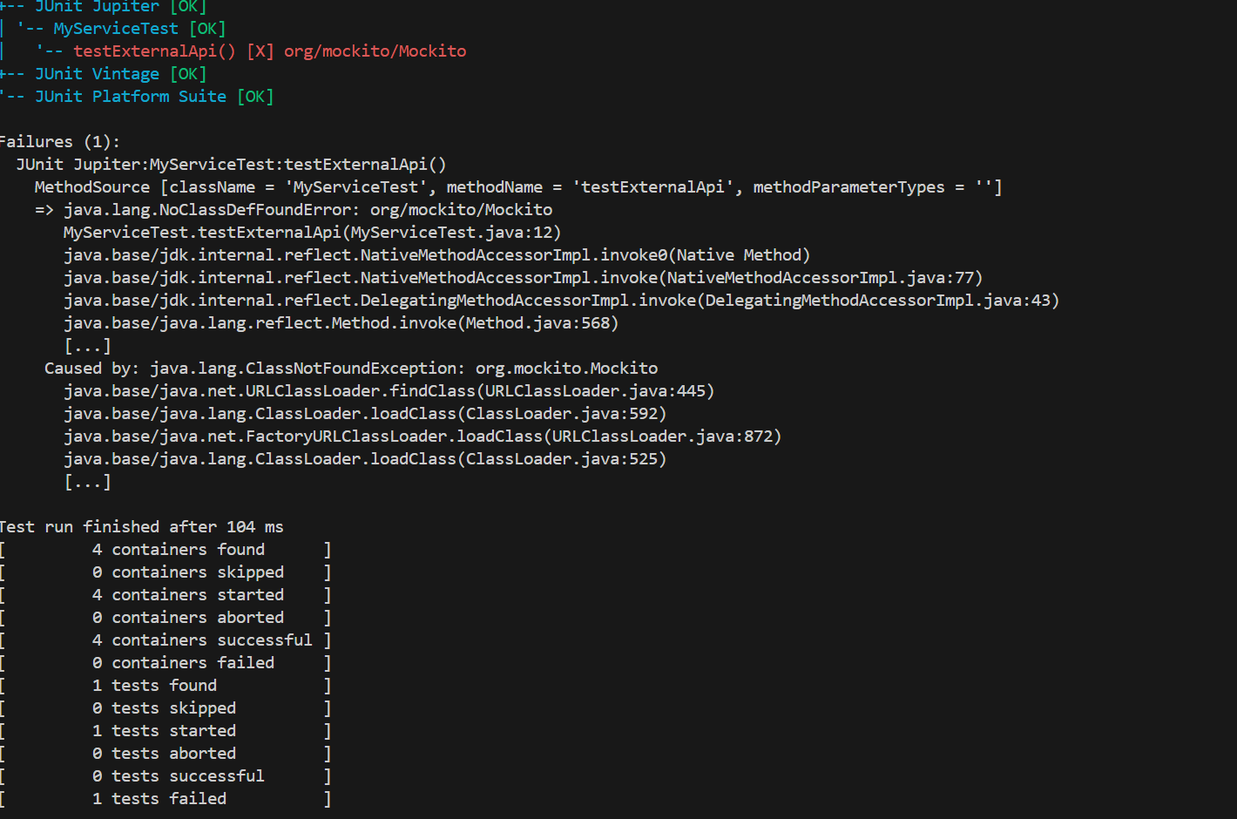

**Exercise 2: Verifying Interactions:**

**ExternalApi.Java:**

package Exercise7_VerifyingInteractions;

public interface ExternalApi {

    void getData();

}

**MyService.java:**

package Exercise7_VerifyingInteractions;

public class MyService {

    private ExternalApi api;

    public MyService(ExternalApi api) {

        this.api = api;

    }

    public void fetchData() {

        api.getData();

    }

}

**MyServiceTest.java:**

package Exercise7_VerifyingInteractions;

import org.junit.jupiter.api.Test;

import static org.mockito.Mockito.*;

public class MyServiceTest {

    @Test

    public void testVerifyInteraction() {

        ExternalApi mockApi = mock(ExternalApi.class);

        MyService service = new MyService(mockApi);

        service.fetchData();

        verify(mockApi).getData();  // Verifying method call

    }

}

**Output:**

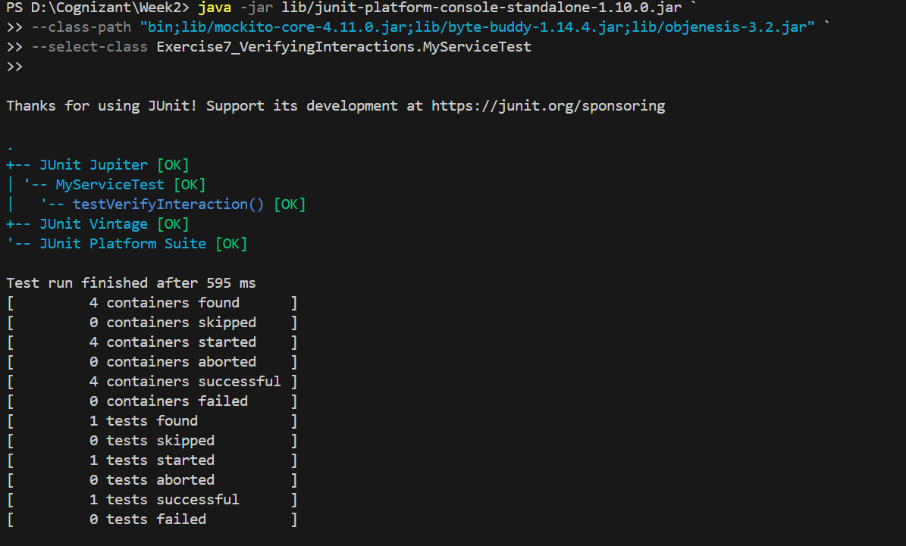

**Logging using SLF4J**

**Exercise 1: Logging Error Messages and Warning Levels:**

package Exercise8_LoggingErrorMessages;

import org.slf4j.Logger;

import org.slf4j.LoggerFactory;

public class LoggingExample {

    private static final Logger logger = LoggerFactory.getLogger(LoggingExample.class);

    public static void main(String[] args) {

        logger.error("This is an error message");

        logger.warn("This is a warning message");

    }

}

**Output:**

